CHAPTER FOUR
DATA ANALYSIS AND DISCUSSION OF RESULTS
4.1 PREAMBLE
This chapter presents the contents of the system developed and explains its basic segments of it as well as the operational guide that will direct the users of the system. The sample output of the system is presented as well relating to the system.
4.2 SYSTEM IMPLEMENTATION
The followings are the sample of the project interface.

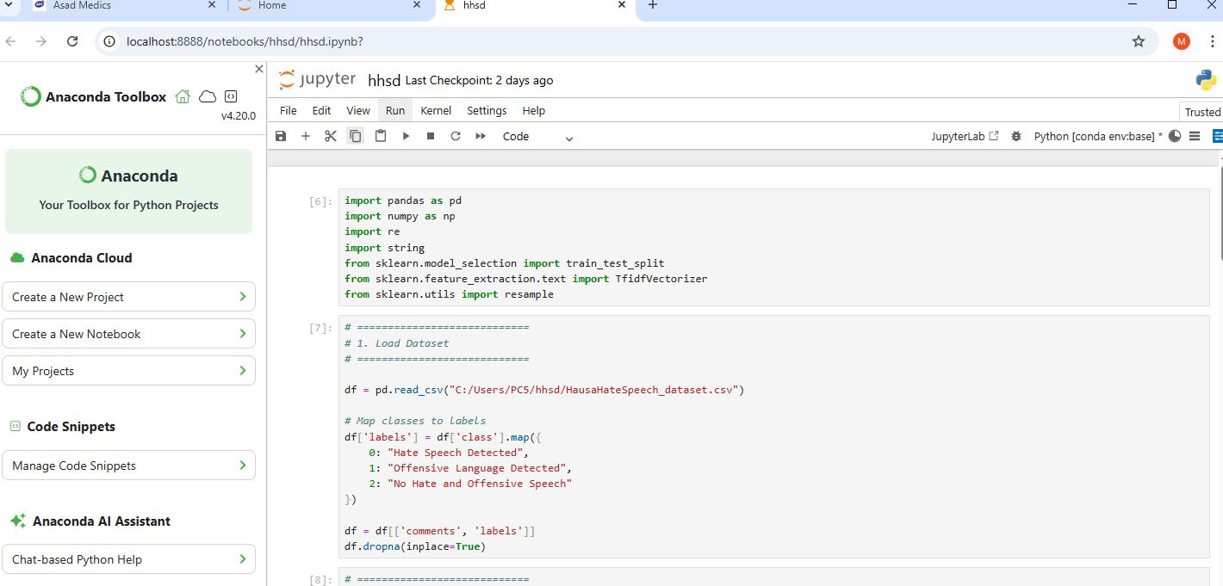
Figure 4.1: Sample of the project interface.

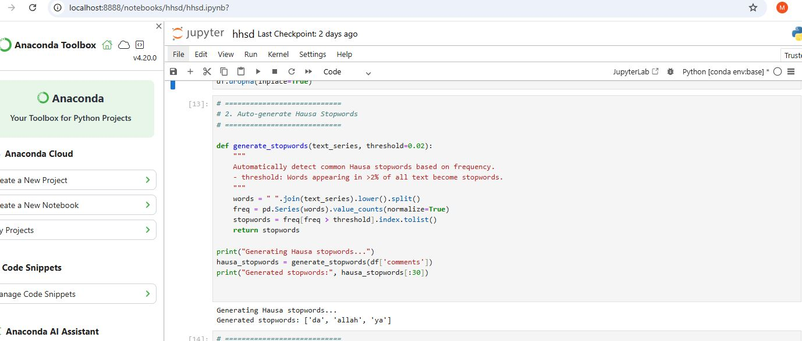

Figure 4.2: Sample of the project interface.

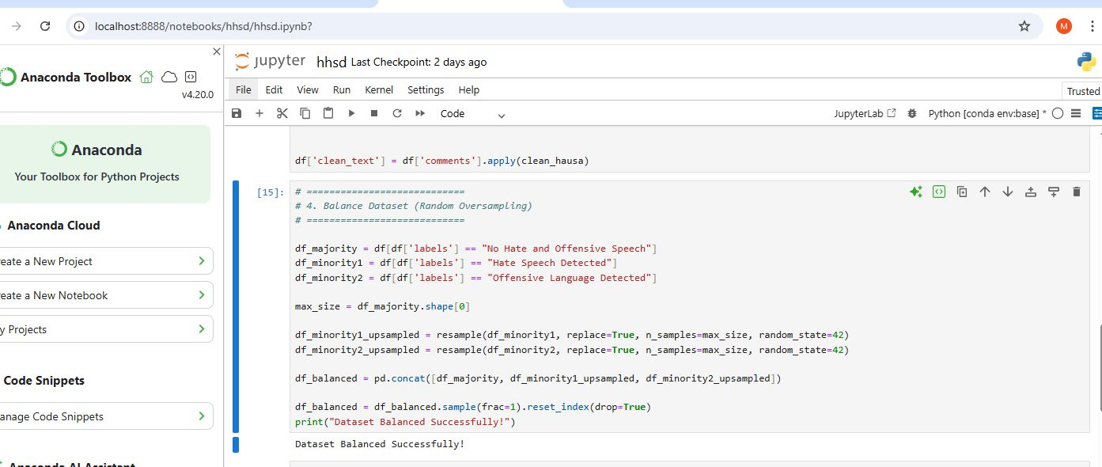
Figure 4.3: Sample of the project interface.

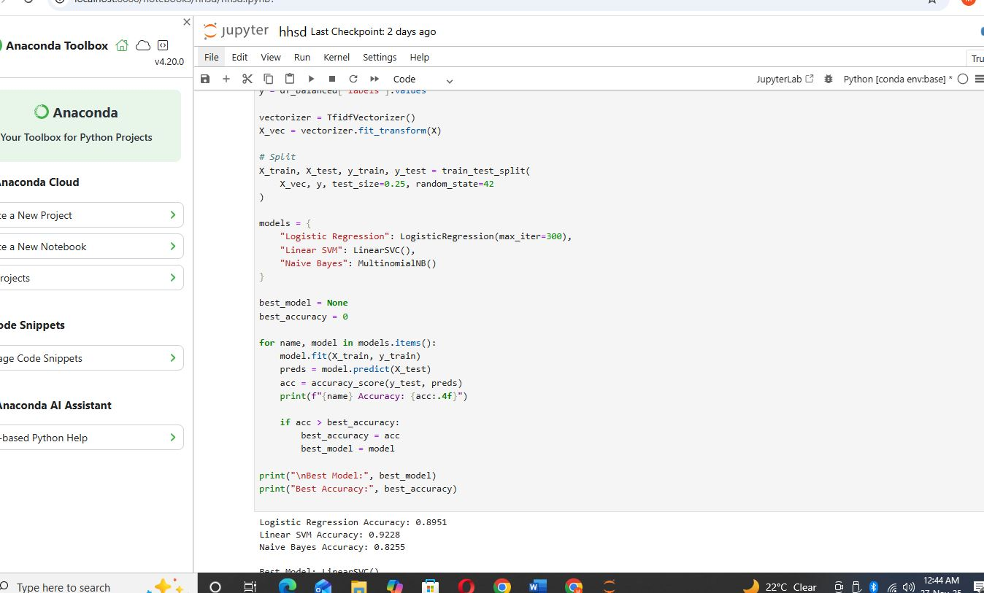
Figure 4.4: Sample of the project interface.

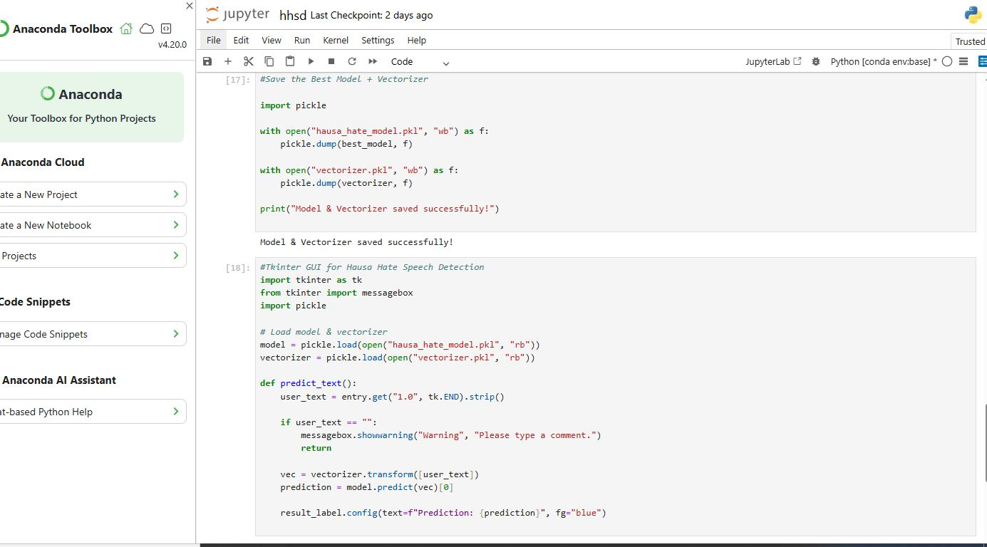
Figure 4.5: Sample of the project interface.

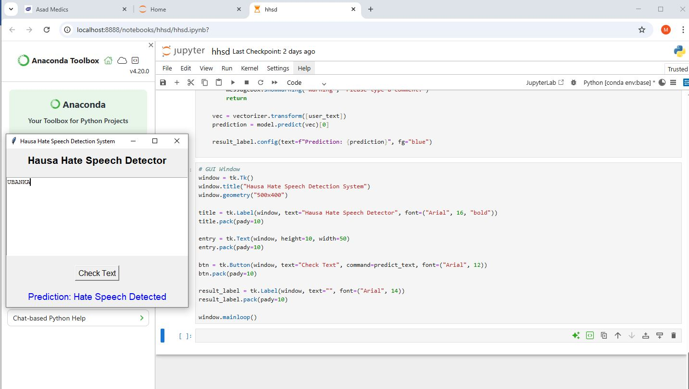

Figure 4.5: Sample of the project interface.

4.3 SYSTEM INSTALLATION
1. Installation: Install Anaconda.
2. Launch: Open Jupyter Notebook by running jupyter notebook in the Anaconda.
3. Execute Installation Commands: Run system-specific installation commands within the terminal of the Jupyter environment.
4. Configuration (if needed): Configure settings or options during or after installation within the Jupyter environment.
5. Functionality Check: Ensure the installed system or software operates correctly within the Jupyter environment.
6. Verify Basic Functions: Test basic functions or features to confirm proper installation.
7. Update and Maintain: Apply any available updates or perform routine maintenance tasks within the Jupyter environment as required by the installed system or software.
4.4 INSTALLING THE PROGRAM FOLDER/FILES
1. Open Jupyter Notebook: Launch Anaconda and click on jupyter notebook in your computer.
2. Navigate to Default Browser: Use the Jupyter interface to access the file system.
3. Create Folders: Use the "New" button to create new folders within the Jupyter file system.
4. Copy and Paste files or folders from your local system into the desired directory in the Jupyter file browser.
5. Check Directory Structure: Confirm that the program folders or files are correctly placed within the Jupyter environment by navigating through the file browser.
6. Access Files: Check access to the installed files within the Jupyter environment to ensure they are available for use.
4.5 RUNNING THE SOFTWARE SYSTEM
1. Open hhsd.ipynb with Notebook Jupyter
2. Run the code
3. Click on run

